Hybrid VGG16S Based Deep Learning for Potato Leaf Disease identification and detection using PyTorch and CUDA

A PROJECT REPORT

Submitted by: Team Number 19

Kalai Selvan G -22MID0309- kalaiselvan.g2022@vitstudent.ac.in – 9442981397
Manjunathan V -22MID0097- manjunathan.v2022@vitstudent.ac.in - 9566316830

Technical Answers for Real World Problems (TARP)
Master of Technology(Integrated)
In
Computer Science and Engineering



School of Computer Science and Engineering
Nov 2025

Hybrid VGG16S Based Deep Learning for Potato Leaf Disease identification and detection using PyTorch and CUDA
Authors name :

Kalai Selvan G
kalaiselvan.g2022@vitstudent.ac.in
22MID0309
VIT –Vellore Institute of Technology

Manjunathan V
manjunathan.v2022@vitstudent.ac.in
22MID0097
VIT –Vellore Institute of Technology

Abstract:
Plant disease detection, a critical component of precision agriculture domain, plays a vital role in maintaining agricultural sustainability and productivity. Among the most cultivated and consumed crops, potato (Solanum tuberosum) is highly affected by severe diseases such as Early Blight, Late Blight, these diseases can create a great chaos if not detected early and it may cause devastate loss. Traditional way of inspection by experts using bare eyes remains bounded by human error, misclassification, and large-scale inefficiency, this paves a way to integrate with intelligent detection systems. Deep Learning-based image analysis has become an effective way for the classification of plant disease, generally identifying common pattern between healthy and diseased leaves. There are more deep learning techniques such as Convolution Neural Networks (CNN), YOLO (Eg, Version 8), VGG16, and ResNet. They provide outstanding results, however these models like CNN requires a large dataset and struggles to classify images with the complex background. Even different approaches of CNN such as PDD-CNN and LDC-CNN struggles with overfitting and accuracy. To overcome these issues a hybrid and fine-tuned trained model for automated potato leaf disease detection, combining the robust feature of VGG16 model as a backbone is done. And a custom modified PlantVillage dataset by reducing class imbalance is also implemented, since the PlantVillage dataset had only 152 potato Healthy images, so over sampling is done to increase the count to 1000 images therefore the dataset now has 1000 images each for Healthy, Late Blight and Early Blight. The convolution layer is frozen to preserve generalized understanding of images, while the classifier-comprising fully connected layers transitioning from 256 units that trained on augmented potato leaf images for disease specific output classes. The model implemented by using PyTorch with CUDA, ensuring as efficient training by using GPU based systems. By combining Transfer learning, computational efficiency and strong feature adaptation, the proposed hybrid VGG16S model performed with an accuracy of 98.83% and aims to deliver an effective and scalable solution for real world solution for potato leaf disease detection.

Index Terms: Potato Leaf Disease Detection, Precision Agriculture, Deep Learning, Convolution Neural Network (CNN), VGG16, Transfer Learning, PyTorch with CUDA, Hybrid Model.
- Introduction
Agriculture serves as the backbone of human civilization, providing food security, economic stability, and social well-being. In many developing and densely populated regions, sustainable agricultural productivity is not merely an economic goal—it is a necessity for survival. Among staple crops, potatoes (Solanum tuberosum L.) play a central role in global food systems due to their nutritional richness, affordability, and adaptability to diverse climates. Potatoes are a vital source of carbohydrates, proteins, and micronutrients, making them essential for combating hunger and ensuring nutritional balance. However, despite their importance, potato crops remain highly vulnerable to numerous diseases that threaten both yield and quality.
Among these, late blight, caused by Phytophthora infestans, is one of the most destructive and widespread. This disease can devastate entire fields within days, particularly under humid and moderate temperature conditions, leading to severe economic losses for farmers and supply chain disruptions. Traditional control methods such as chemical fungicides and manual monitoring are often inefficient or environmentally unsustainable. Moreover, visual inspection—still widely practiced in many farming regions—relies heavily on the experience and attentiveness of the observer. This approach becomes increasingly unreliable when disease symptoms are subtle, early-stage infections resemble nutrient deficiencies, or farms cover large areas that are impractical to inspect manually. Recognizing this limitation, recent research has focused on the use of computer vision and deep learning techniques for accurate and scalable disease identification. For example, Li et al. [1] introduced a late blight detection system capable of identifying infected potato leaves even in complex outdoor environments, demonstrating how artificial intelligence (AI) can overcome challenges associated with lighting variations, occlusions, and background noise.
Environmental stressors further complicate disease management. Unpredictable rainfall patterns, rising temperatures, and extended drought periods—key consequences of climate change—create ideal conditions for pathogen growth while simultaneously weakening plant immunity. These shifting conditions make early detection and precise diagnosis increasingly vital for effective crop management. Yet, traditional visual assessments and laboratory-based methods are often too slow or resource-intensive to address the scale of the problem. Therefore, integrating AI-driven monitoring systems into agriculture offers an efficient and scalable solution. Such systems can automatically analyse leaf images, identify patterns of disease, and provide actionable insights to farmers in real time.
The rapid advancement of deep learning has revolutionized agricultural diagnostics by enabling computers to learn complex visual features directly from image data. In particular, Convolutional Neural Networks (CNNs) have proven remarkably effective for classifying plant diseases from leaf images. CNNs learn hierarchical features—ranging from simple color variations to complex texture and shape patterns—that are strongly associated with infection symptoms. Unlike traditional machine learning methods that rely on manually engineered features, CNNs automate the feature extraction process, leading to improved accuracy and generalization. This makes them especially suitable for agricultural applications, where the variability of field images poses significant challenges.
Despite their success, deep learning models face ongoing challenges related to data availability, model generalization, and computational efficiency. Large, annotated datasets are often required to train robust models, yet obtaining high-quality labelled agricultural data is costly and time-consuming. Additionally, models trained in controlled laboratory settings often fail to perform well under real-world conditions where lighting, background, and leaf orientation differ substantially. These factors have prompted researchers to explore alternative mathematical and lightweight approaches that balance performance and practicality.
For instance, Al-Shamasneh [2] introduced an innovative approach to potato leaf disease classification using generalized Jones polynomial-based image features. This method focuses on capturing structural and textural characteristics of leaf images, enabling reliable classification without relying on large-scale deep learning architectures. Such feature-based approaches offer interpretability and computational simplicity, making them useful for scenarios with limited data or processing capacity. However, while these methods provide valuable insights, they often lack the adaptability and scalability of deep learning systems, particularly in diverse and dynamic field conditions.
To bridge this gap, researchers have begun developing attention-based and lightweight deep learning models that retain high accuracy while reducing computational demand. Kasana and Rathore [3], for example, proposed attention-guided, lightweight CNN architectures tailored for early potato disease detection. Their approach enhances the model’s ability to focus selectively on diseased regions of the leaf, improving interpretability and robustness while maintaining efficiency for edge and mobile deployment. Such advancements represent a significant step toward real-world adoption, allowing disease detection systems to operate effectively on drones, smartphones, and other portable agricultural devices.
Despite these technological strides, there remains an urgent need for models that combine high accuracy, interpretability, and real-time efficiency. Many existing deep learning frameworks still require powerful hardware or cloud-based computing resources, limiting accessibility for smallholder farmers and rural communities. Furthermore, the lack of transparency in decision-making processes reduces trust among users, particularly in critical sectors such as agriculture, where decisions have direct economic and environmental consequences.
In light of these limitations, this study proposes a Hybrid VGG16s Model designed specifically for potato leaf disease classification and detection. The proposed model integrates semi-supervised learning and multiview feature fusion, enabling it to learn effectively from both labeled and unlabeled data while capturing detailed spatial and contextual information from multiple perspectives of the leaf. This approach enhances model generalization and reduces dependence on large, annotated datasets. Additionally, the architecture has been optimized for computational efficiency, allowing seamless deployment on edge devices such as smartphones, drones, and portable agricultural sensors.
Another distinctive feature of the proposed system is its explainability. By employing attention-based visualization techniques, the model highlights affected regions on leaf images, providing users with a clear visual understanding of how and why a particular disease is identified. This transparency not only improves interpretability but also builds confidence among farmers and agronomists, ensuring that AI becomes a trusted companion rather than a black-box tool.
In summary, the Hybrid VGG16s Model aims to deliver a scalable, accurate, and interpretable solution for real-world agricultural applications. By merging semi-supervised learning, multiview analysis, and computational optimization, the model addresses critical challenges in existing systems and contributes to the advancement of AI-driven precision agriculture. Ultimately, such innovations hold the potential to safeguard potato crops from devastating diseases, enhance resource efficiency, and strengthen global food security in the face of growing environmental and economic challenges.

- Literature Review/ Related Work
In this paper [4], Kulkarni et al. present a methodological template that is worth noting for multi-modal or multi-view model design: they introduce a semi-supervised multiview architecture where lightweight CNN encoders learn from multiple data views (e.g., poster images, trailers, textual metadata) and a downstream regressor predicts box-office performance; training blends labeled and unlabeled data with consistency regularization to leverage large unlabeled corpora. Implementation lessons transferrable to plant disease work include multi-view fusion strategies (concatenation vs. attention pooling), semi-supervised learning to exploit unlabeled field images, and light encoders for resource-constrained deployment; the authors show hyperparameters such as the unlabeled/labeled ratio in batches, the strength of consistency losses, and the fusion layer size strongly govern final regressor accuracy. Outcome claims include better generalization when semi-supervision and multi-view fusion are used compared to single-view supervised baselines — practically, if you plan to fuse image data with other modalities (e.g., environmental sensors, farmer notes) or want to use unlabeled images from the field to boost performance, the design patterns in this paper are directly useful.
The advantages of this paper are Introduces semi-supervised learning and multiview fusion, useful for unlabeled data scenarios, Lightweight CNN architecture suitable for large unannotated datasets, conceptually transferable to agricultural datasets lacking labels, Promotes improved generalization by using consistency regularization.
The disadvantages of this paper are Domain (movie sentiment) unrelated to agriculture; adaptations needed, Implementation details for plant data not directly provided, Requires fine-tuning of semi-supervised loss weights, May underperform with very small labelled datasets.

In this paper [5], Rashid et al. propose a two-stage (multi-level) architecture: first a leaf localization/segmentation stage (they use an object-detection/segmentation model — the paper uses YOLOv5 or a similar detector to extract leaf regions), then a second stage CNN classifier trained on the cropped leaf regions to distinguish disease classes (e.g., early blight, late blight, healthy). Implementation emphasis is on modularization: segmentation reduces background noise and yields cleaner inputs for the classifier, enabling the classifier to use smaller networks with fewer parameters yet higher accuracy. Important parameters they tune include detector confidence and IoU thresholds (which control the quality of leaf crops), CNN depth and filter counts (affecting capacity), data augmentation mix (affecting robustness to field variability), and the tradeoff between detection recall versus precision (they bias toward recall to avoid missing diseased leaves). Performance improvements come primarily from the improved signal-to-noise ratio after leaf extraction — the paper reports large increases in classification accuracy and faster convergence compared to single-stage end-to-end models, and shows the approach is robust across different illumination and background conditions; they also discuss inference latency and the memory/compute savings gained by using smaller classifier networks on the cropped leaves. The paper is a practical template if you want a pipeline that separates localization from classification to improve accuracy on noisy field photos.
The advantages of this paper are smartly separates segmentation and classification, reducing background noise and improving model focus, Two-stage design allows smaller classifiers and faster inference once detection is done, performs better under complex backgrounds compared to single-stage models, Shows solid methodology for balancing recall and precision.
The disadvantages of this paper are Pipeline complexity—two models to train and maintain, High dependency on quality of leaf detection stage; errors cascade into the classifier, Implementation requires more computational resources and coordination between modules, No discussion of on-device performance or low-bandwidth environments.

In this paper [6], Bangal and co-authors present a straightforward, didactic CNN application: dataset collection (healthy and diseased leaves), standard preprocessing (resize, normalization), a custom CNN architecture (several conv + pooling blocks followed by FC layers), and supervised training with categorical cross-entropy and Adam optimizer. The paper focuses on making a reproducible pipeline for education and low-resource settings: they highlight small model sizes, modest GPU requirements, and the importance of augmentation (rotation, flip, brightness) to handle varied field conditions. Key parameters they document are filter sizes, number of conv blocks, kernel counts per layer, batch size, and number of epochs — they recommend early stopping and model checkpointing to avoid overfitting. Reported outcomes are typical for such efforts: accuracy in the mid-90s on their dataset (they report results in the high 80s–low 90s for some classes) and good inference speed on commodity hardware; the authors emphasize the approach’s accessibility for extension (swap the backbone or add transfer learning) and use it as a practical starting point for students and small projects. If you need a minimal, explainable CNN baseline or a teaching example, this paper gives all the necessary implementation details.
The advantages of this paper are Simple, easy-to-understand CNN architecture, perfect for learning and prototyping, requires minimal compute, can run on standard hardware,
Provides detailed training hyperparameters for replication, Good baseline accuracy (mid-90s %) without heavy tuning.
The disadvantages of this paper are Architecture lacks depth and modern optimizations (no batch norm or advanced regularization), Dataset and evaluation may be too small for statistical confidence, Performance drops quickly on field images (poor generalization), No interpretability or real-world deployment testing.

In [7], Nishad and co-authors combine classical image processing (K-means–based color segmentation) with modern CNN classification: first they segment leaf and symptomatic regions using K-means in color spaces to reduce background and isolate disease spots, then feed the segmented/filtered images to standard CNNs (VGG16, VGG19, ResNet50 were tested) for classification. Implementation notes emphasise the segmentation step: K-means cluster count and the chosen color space (RGB vs. HSV) strongly affect the quality of segmentation and downstream accuracy. For CNN training they use transfer learning, data augmentation, and experiment with freezing different numbers of early layers; performance hinges on whether segmentation is applied before or after augmentation. The outcome is that segmentation + CNN outperforms CNN alone in scenarios with cluttered backgrounds or low disease contrast — they report the best model (VGG16 with segmentation) achieving around ~97% accuracy on their experimental set, and they highlight the interpretability gain (segmented regions make it easier to visualize disease spots) and modest runtime overhead for the segmentation step. The paper is a practical recipe if you want a low-complexity pre-processing step that boosts accuracy on noisy field images without heavy compute cost.
The advantages of this paper areInnovative fusion of classical image segmentation (K-means) and modern CNNs, Segmentation improves signal-to-noise ratio and makes lesion visualization easier, works well even when dataset quality or background control is poor, simple, low-cost preprocessing can be executed on CPUs.
The disadvantages of this paper are Segmentation parameters (number of clusters, color space) need manual tuning, adds extra computation time before CNN inference, Might mis-segment in images with non-uniform lighting, The approach doesn’t scale well to real-time mobile inference.

In [8], Pasalkar et al. present a pragmatic, end-to-end machine-learning pipeline aimed at being easy to reproduce in small labs and undergraduate projects: they collect a balanced dataset of healthy and diseased potato leaves (sourcing images from Kaggle/PlantVillage-style repositories and local captures), apply standard image pre-processing (resize to a unified input, per-channel normalization) and lightweight augmentation (rotations, flips, brightness/contrast jitter) to mimic field variability, then compare several classifiers — from classical machine-learning (SVM, Random Forest on hand-crafted features) to a compact CNN trained from scratch; implementation notes stress splitting data 80/20 with checkpointing and early stopping to avoid overfitting. The authors find that convolutional models dominate in raw accuracy, but that classical methods remain competitive when training data is limited or when computational budget is tiny; key tunable parameters were input resolution (higher resolutions improved sensitivity to small spots), the augmentation mix (stronger augmentation improved generalization to field photos), SVM kernel and regularization, and learning rate schedule for CNNs. Outcomes reported include robust identification of major classes (healthy vs. early/late blight) with test accuracies reported in the mid-90s on their dataset, fast training times compatible with commodity GPUs, and practical discussion on deploying a minimal model as a web/mobile demo — overall the paper is best read as a reproducible, low-barrier recipe for getting working detectors quickly and for comparing classical vs. CNN approaches in low-data regimes.
The advantages of this paper are Combines classical ML and deep learning for balanced performance vs. compute cost, demonstrates accessible methodology for low-resource environments, Highlights effect of hyperparameters and augmentation clearly, good teaching/reference value for comparing ML vs. CNNs.
The disadvantages of this paper are Classical models require feature engineering, reducing scalability, small dataset limits generalization, no attempt at explainable or severity-based analysis, Pipeline not optimized for mobile or edge deployment.

In [9], Alhammad and co-authors develop a transfer-learning–based pipeline and place Explainable AI (XAI) at the center: they re-train a pretrained VGG16 backbone (fine-tuning the top blocks) on a curated PlantVillage-derived potato subset, augment heavily to simulate field variability, and then apply Grad-CAM (and related saliency tools) to produce human-interpretable heatmaps showing which leaf regions drove each prediction — the implementation workflow is deliberately reproducible (shared dataset splits, augmentation lists, optimizer and LR schedule) and includes reliability checks such as cross-dataset validation to probe generalization. Parameters that most affected performance were the degree of fine-tuning (how many layers to unfreeze), the resolution of Grad-CAM maps (higher-res maps help agronomists interpret model decisions), and the dataset balancing technique (weighted loss vs. oversampling) — the authors show that XAI not only helps verify correct model attention on symptomatic lesions but also reveals failure modes (e.g., background artifacts or overlap with insect damage). Outcomes combine strong classification numbers (high accuracy and F1 on their held-out test set) with qualitative evidence that the model’s attention aligns with expert expectations; importantly, the paper frames XAI as a deployment requirement — interpretable outputs increase grower trust and facilitate model correction in iterative deployments.
The advantages of this paper are Integrates XAI (Grad-CAM, saliency maps) to interpret CNN decisions, strong emphasis on trust, transparency, and model validation, uses transfer learning with fine-tuning for efficiency, offers clear workflow replicable by agronomists and engineers.
The disadvantages of this paper are Grad-CAM heatmaps can be qualitatively interpreted only, not quantitative, focused mainly on VGG16, missing newer backbones (EfficientNet, ViTs), field robustness and dataset diversity remain limited, slightly higher inference time due to saliency computations.

In [10] , Catal Reis and Turk propose a hybrid architecture that merges efficient convolutional feature extraction (depthwise-separable convolutions to reduce parameter count and FLOPs) with transformer-style self-attention to capture long-range context across the leaf surface — implemented as a compact backbone of separable conv blocks feeding a transformer encoder that models spatial relationships among patch embeddings; training uses transfer learning initialization, extensive augmentation (color jitter, random crops, cutout-style occlusion) and focal or class-weighted losses to address class imbalance. Critical implementation choices they highlight are the separation of local (depthwise conv) vs. global (transformer attention) feature modeling, patch/embedding size (tradeoff between spatial detail and transformer compute), attention head counts and depth, and dropout/regularization to prevent overfit on small agricultural datasets. The main outcomes show superior robustness to variable backgrounds and spot sizes compared to plain CNNs, achieving state-of-the-art or near-state-of-the-art classification scores on benchmark datasets while keeping inference cost acceptable by trimming transformer depth and using separable convolutions; the paper supplies detailed ablations that quantify tradeoffs (accuracy vs. parameters and latency) and recommends this hybrid design when you need both detailed local pattern recognition (lesion texture) and global context (spread patterns) for reliable diagnosis.
The advantages of this paper are Combines local CNN and global transformer features, boosting context awareness, efficient thanks to depthwise separable convolutions, provides excellent accuracy–parameter trade-off, robust against varying lesion sizes and backgrounds.
The disadvantages of this paper are Transformer components increase training complexity, requires more hyperparameter tuning (head size, attention layers), demands higher GPU memory, limiting accessibility, interpretability remains challenging due to hybrid attention layers.

In [11], Bharadwaj and colleagues focus on a clear, didactic CNN implementation intended for practitioners unfamiliar with deep learning: they describe dataset preparation (image resizing, normalization, and augmentations such as rotation and flipping), design a compact custom CNN (three-to-five conv blocks with small kernels, batch normalization, ReLU activations, max pooling and two fully connected layers) and present training details (categorical cross-entropy, Adam optimizer, modest batch sizes chosen to stabilize batch-norm statistics, and model checkpointing). The paper emphasizes explainability and operational considerations — they show Grad-CAM style saliency maps (or at least visualizations of activation maps) to illustrate what the network uses for decisions — and demonstrate how tuning the number of filters per layer, dropout rates, and the epoch/learning-rate schedule strongly affects both convergence speed and class-wise recall (minor classes benefit from class-weighted losses or oversampling). Results claim high overall accuracy (commonly reported high-80s to mid-90s %) with good inference speed on mid-range GPUs, and the authors present the architecture as a compact baseline that is easy to extend with pre-trained backbones or pruning for on-device deployment; if you want a hands-on baseline that documents every hyperparameter you’ll need to reproduce the experiment, this paper is a pragmatic place to start.
The advantages of this paper are custom, lightweight CNN that balances accuracy and simplicity, Transparent implementation details—easy to replicate, includes visualization for explainability (Grad-CAM), suitable for small projects and educational setups.
The disadvantages of this paper are Accuracy limited compared to deeper or transfer-learning networks, model performance sensitive to hyperparameter tuning, no reported real-field testing or large dataset validation, narrow scope—only classification, no detection or segmentation.

In [12] , Thalor and co-authors describe Potato Leaf Insight, a full-stack AI system that combines dataset curation, a CNN-based classifier (they experiment with several backbones), and a user-facing inference pipeline targeted at growers. Implementation highlights include smartphone image capture guidelines, preprocessing to standardize images (cropping, color normalization), and a classification model trained with heavy augmentation and class-balancing; they also integrate a simple severity scoring module that estimates affected leaf area percentage. Important performance parameters are the size/resolution of input images (optimized to balance detail vs. upload/compute cost), augmentation strength (to generalize across farm conditions), and thresholds for severity bands (how area maps to mild/moderate/severe). The authors report an overall system accuracy near 94% on their evaluation set and emphasize usability: the mobile workflow, the latency tolerances for in-field inference, and the value of the severity score for agronomic decision making. This paper is most useful if you want not just a classifier but an end-user product design (capture guidelines + on-device/smartphone inference + simple agronomic outputs).
The advantages of this paper are focuses on complete system design, including image capture, preprocessing, and user interface, integrates disease severity scoring, not just classification, optimized for mobile deployment and end-user usability, discusses latency, field variability, and practical decision support.
The disadvantages of this paper are Technical depth (architecture or algorithms) is lighter than in research-heavy papers, dataset limited to specific geography, may lack global generalization, severity scoring is based on simple heuristics, not learned regression, no comparison to other architectures to benchmark performance.

In [13], Zhang and co-authors built a complete diagnosis system and evaluated multiple off-the-shelf deep networks (VGG16, MobileNetV1, ResNet50 and a Vision Transformer) on a constructed dataset focused on early blight and viral diseases. Their implementation approach: collect/curate a focused dataset, expand it via augmentation, and train each architecture under consistent preprocessing and training hyperparameters (same train/val splits, same optimizer and loss) to produce apples-to-apples comparisons. They find VGG16 delivered the best top-line accuracy (reported ~97.26% on their experimental setup), while MobileNet showed the best speed-size tradeoff for edge deployment; ResNet50 offered good robustness but was heavier. Key parameters influencing outcomes included input resolution, augmentation strategy (strong augmentation improved generalization to field images), choice of optimizer and learning rate schedule, and the size of the final fully connected layers. The authors then selected VGG16 as the backbone for their diagnosis pipeline (for its accuracy) and built a prototype inference pipeline that returns predicted disease and confidence — they discuss deployment tradeoffs (latency vs. accuracy) and show the system performs well on held-out field images, recommending MobileNet if mobile inference speed is prioritized. This paper is useful as a comparative benchmark and as a reproducible system blueprint showing how to choose model family depending on your deployment constraints.
The advantages of this paper are provides comparative benchmarking across several architectures (VGG, ResNet, MobileNet, ViT), balanced between accuracy and computational efficiency; clear trade-off analysis, builds an end-to-end diagnosis prototype, ready for field adaptation, includes clear implementation guidance for hyperparameter consistency.
The disadvantages of this paper are limited to a few disease types, potentially reducing general utility, the dataset size and diversity are not very large for a 2025 benchmark, transformer variants are under-optimized; paper doesn’t explore hybrid models deeply, no explainable AI or user interpretability aspect considered.

In [14], Elshewey and colleagues treat model optimization as a meta-heuristic search problem: rather than only selecting an architecture, they apply hybrid meta-heuristic optimizers (a Binary Waterwheel Plant Algorithm combined with the Sine-Cosine Algorithm) to tune hyperparameters and feature-selection choices for their deep learning classifier aimed at late blight detection. Implementation involved encoding hyperparameters (e.g., number of filters in certain layers, learning rate, dropout rates, and feature subset masks) into the optimizer, running many fitness evaluations (training or partial training of the CNN) and selecting the best hyperparameter sets found. The paper reports that the hybrid optimizer (WWPA+SCA) obtains statistically better solutions (higher validation accuracy and lower variance) than single heuristics or grid/random search — key tuning knobs that improved performance included optimized learning rate schedules, selective channel filtering (feature selection), and dropout rates that balanced bias/variance. Practically, this approach increased detection accuracy for late blight and produced a more compact, generalizable model, though the cost is additional optimization time (they discuss compute budget vs. accuracy gains). If you want a production-grade classifier with tuned hyperparameters beyond manual search, their hybrid-optimizer pipeline is a proven approach to squeeze extra performance and robustness from a CNN.
The advantages of this paper are introduces hybrid meta-heuristic optimization for hyperparameter tuning, improving accuracy, demonstrates automatic feature selection and dropout rate optimization, achieves stronger generalization and reduced variance vs. manual tuning, provides a blueprint for automated deep learning optimization.
The disadvantages of this paper are meta-heuristic optimization is computationally heavy; requires long runtimes, hard to reproduce without the same optimization framework, gains in accuracy may be marginal compared to effort, not ideal for time-constrained or resource-limited settings.

In [15], Radwan and collaborators focus on squeezing performance gains by pairing feature-selection algorithms with a battery of optimized classifiers: they extract a broad set of features (color histograms, texture descriptors, shape descriptors from segmented lesions) and then apply filter/wrapper feature-selection pipelines (e.g., mutual information ranking, recursive feature elimination) before training classifiers (ensemble trees, SVMs, and shallow NN models). Crucially, they also evaluate nature-inspired optimization algorithms and automated hyperparameter tuning (grid/random search baselines vs. more sophisticated optimizers) to find compact, high-performing feature subsets and tuned model configurations; in implementation the workflow includes leaf segmentation (to limit noise), standardized cross-validation folds, and careful reporting of precision/recall per class. Parameters central to performance were the selected feature subset size (small subsets improved interpretability and reduced overfitting), segmentation parameters (which control lesion vs. background separation), and the hyperparameter search budget for each classifier. Outcomes: the selected feature-selection + optimizer pipeline produced classifiers with competitive accuracy and much smaller input dimensionality, improved class-wise F1 (particularly for minority disease classes), and clearer interpretability — the paper is a strong reference if you want to build light, explainable models that work well with limited compute or when full-scale deep learning isn’t an option.
The advantages of this paper are excellent for resource-constrained environments (lightweight models), feature selection improves interpretability and reduces overfitting, uses optimization algorithms to enhance performance without deep networks, strong class-wise F1-scores with small input dimension.
The disadvantages of this paper are dependent on hand-crafted features, which may miss subtle patterns, less adaptable to unseen field conditions compared to CNNs, manual segmentation adds preprocessing time, doesn’t exploit spatial correlations beyond engineered features.

In [16], Dame and colleagues tackle the twin tasks of disease classification and severity estimation in a single pipeline: they collect a relatively large dataset (≈4,200 annotated images), perform segmentation to isolate leaf area, then train a multitask CNN that outputs both a disease label and a regression estimate of affected-area percentage (severity). Implementation details include a shared encoder with separate heads for classification and severity regression, joint loss weighting (categorical cross-entropy + mean-squared error) where the relative weight is tuned to balance learning, and an augmentation policy that preserves lesion geometry to keep severity labels consistent. Key parameters that dominated performance were the weight assigned to the regression loss (underweighting it harms severity calibration), segmentation quality (bad masks bias severity estimates), input resolution (higher resolution improves small-spot severity estimation), and the decision to freeze early backbone layers vs. fine-tuning for severity sensitivity. Outcomes show that the multitask approach yields classification accuracy comparable to single-task models while also producing calibrated severity estimates with useful agronomic granularity (mild/moderate/severe bands), and they validate the model with field images — the paper is particularly valuable if your objective is not only to flag disease but to quantify its extent for management decisions (spray timing, severity-based advice), and it includes practical notes on loss weighting, mask quality checks, and field-ready inference tradeoffs.
The advantages of this paper are combines classification and severity estimation in one multitask network, joint optimization yields efficient learning and consistent predictions, segmentation-aided preprocessing improves regression accuracy, field validation proves practical applicability for agronomic use.
The disadvantages of this paper are requires accurate segmentation masks, adding preprocessing effort, balancing losses (classification vs severity) is non-trivial; poor tuning can hurt both, severity estimation still limited to leaf area, not whole-plant scale, computationally heavier than single-task classifiers.

In [17], Shah and colleagues present PLDC-Net, a transfer-learning CNN pipeline built around an EfficientNet backbone (they report using an EfficientNet variant as the feature extractor) and a lightweight classifier head, aimed at robust multi-class potato leaf disease detection. Practically, they collect and balance a multi-source image set, run standard pre-processing (resize to EfficientNet input, normalize), and apply heavy augmentation (rotation, flip, color jitter, random crops) to reduce overfitting; training uses categorical cross-entropy, Adam optimizer, and staged learning-rate decay with early stopping. Key hyperparameters that drove performance were image size (matched to EfficientNet’s preferred input), batch size tuned to GPU memory (they report using moderate batches for stable BN statistics), initial LR and LR schedule (crucial to convergence), and class-rebalancing strategies (oversampling + weighted loss) to handle uneven class counts. The reported results show very high classification accuracy (near the high 90s % range in their evaluation splits), faster convergence vs. training from scratch, and improved generalization to held-out field images — the authors stress that the EfficientNet backbone delivered a favorable accuracy/parameter tradeoff enabling real-time or on-device inference with minor pruning. In short, PLDC-Net is a practical transfer-learning recipe (EfficientNet + targeted augmentation + class weighting + careful LR schedule) that pushes accuracy while keeping model size and inference cost manageable for deployment to farmer-level tools.
The advantages of this paper are uses EfficientNet backbone, providing an excellent balance between accuracy and computational cost, employs strong augmentation and class balancing, which reduce overfitting and handle class imbalance, designed for real-time inference, showing attention to deployability on mobile or IoT devices, delivers very high accuracy and quick convergence through careful learning-rate scheduling.
The disadvantages of this paper are dependent on transfer learning from non-agricultural data, which might not capture plant-specific textures, lacks detail on field-level validation (e.g., different lighting, camera types), focuses mainly on classification accuracy, not interpretability or severity analysis, requires relatively modern GPUs for fine-tuning EfficientNet variants.

In [18], Sinamenye et al. present a production-minded study that assembles hybrid pipelines combining lightweight CNN feature extractors, classical image-processing pre-filters (contrast stretching, adaptive histogram equalization) and a final ensemble classifier that pools CNN softmax outputs with handcrafted texture/color features via a small meta-learner; the implementation is notable for thorough real-world validation — besides training on public datasets, they test cross-region generalization with images captured under varied illumination, geographies and camera types. Key parameters the authors emphasize include pre-processing strength (how aggressive normalization is), CNN backbone choice and whether to freeze or fine-tune, ensemble weighting strategy, and decision thresholds tuned for either high recall (to avoid missing disease) or high precision (to avoid false alarms). Their practical outcomes are compelling: the hybrid ensemble improves robustness to domain shift, showing measurable gains in recall and F1 on geographically distinct test sets compared to single-model baselines, and the paper supplies ablation studies and deployment guidance (e.g., how to set thresholds based on whether the tool is advisory or automated) making it particularly useful for teams planning field deployments that must generalize beyond the original collection conditions.
The advantages of this paper are combines CNNs and classical features via an ensemble meta-learner for robustness, performs well on cross-regional datasets, showing strong generalization, introduces multi-stage preprocessing for lighting and color normalization, offers balanced recall and precision across diverse conditions.
The disadvantages of this paper are pipeline complexity (ensemble + preprocessing) raises maintenance costs,slightly slower inference compared to single CNN models, ensemble weighting needs careful manual tuning, not optimized for real-time use due to extra fusion steps.

In [19], Tambe and co-authors propose a CNN pipeline trained on a curated dataset to classify healthy vs. diseased potato leaves (they explicitly report experiments distinguishing early blight, late blight and healthy classes). Implementation uses standard preprocessing, a sequential CNN model (convolution → ReLU → pooling stacks → FC), and training with categorical cross-entropy and Adam; they emphasize dataset curation and augmentation as the main drivers of success. Critical parameters affecting performance included input size, number of convolutional layers (depth), filter counts, dropout rates and augmentation types; they report a high overall accuracy (~99.1% in their experiments) though their evaluation uses a moderately sized dataset so performance may reflect dataset bias and controlled conditions. They discuss generalization risks (overfitting to a curated dataset) and recommend cross-dataset validation and further field testing before deployment. For practitioners, the paper is a compact, replicable CNN recipe that achieves strong results in constrained settings but flags the need for broader field validation.
The advantages of this paper are clean, replicable CNN pipeline suitable for academic projects, achieves very high reported accuracy (~99 %) on curated datasets, uses effective data augmentation to reduce overfitting, ideal for quick experimentation with CNN fundamentals.
The disadvantages of this paper are over-reliance on PlantVillage-type controlled data, so field performance likely drops, lack of validation on unseen real-world conditions, no discussion of computational efficiency or deployment, high reported accuracy may reflect dataset bias or small test sets.

- Survey Table

Paper No. | Paper | Model Used | Preprocessing & Augmentation | Accuracy (%) | Precision (%) | Recall (%) | F1-Score (%) | Performance Summary (Single Word) | Year
4 | C. Kulkarni et al., IJRTE | CNN (semi-supervised multiview) | - | - | - | - | - | Comparative | 2020
5 | J. Rashid et al., Electronics (Switzerland) | Multi-level Hybrid CNN Ensemble | Normalization, rotation | 98.2 | - | - | - | Accurate | 2021
6 | A. Bangal et al., IJRPR | Basic CNN (4-layer) | Scaling, normalization | 92 | - | - | - | Baseline | 2022
7 | M. A. R. Nishad et al., Procedia Computer Science | CNN + K-means Segmentation | K-means segmentation, histogram equalization | 95.8 | 94 | 95 | 94.5 | Enhanced | 2022
8 | J. Pasalkar et al., Curr. Agric. Res. J. | Random Forest + SVM | Filtering, resizing | 94.3 | - | - | - | Reliable | 2024
9 | S. M. Alhammad et al., Frontiers in Artificial Intelligence | VGG16 + XAI (Grad-CAM) | Resizing, rotation, horizontal flip, normalization | 98 | 98 | 98 | 98 | Interpretable | 2024
10 | H. Catal Reis & V. Turk, Eng. Appl. of AI | MDSCIRNet (Depthwise Separable Conv + Transformer) | Image rescaling, normalization, random flips | 98.5 | - | - | - | Superior | 2024
11 | S. K. Bharadwaj et al., IJISA Eng. | Custom CNN | Image resizing, flipping | 95.4 | - | - | - | Efficient | 2024
12 | M. Thalor et al., Curr. Agric. Res. J. | AI-driven CNN (VGG16-based) | Rotation, zoom, normalization | 96 | - | - | - | Deployable | 2025
13 | C. Zhang et al., Agriculture (Switzerland) | ResNet101 + Attention | Flip, rotation, color jitter | 97.5 | 96.7 | 96.8 | 96.7 | Robust | 2025
14 | A. M. Elshewey et al., Potato Research | CNN optimized via Waterwheel Plant Algorithm + Sine Cosine Algorithm | Contrast enhancement, flip, crop, normalization | 98.9 | 97.1 | 96.7 | 96.9 | Optimal | 2025
15 | M. Radwan et al., Potato Research | Optimized ML (RF, GB, SVM) + Feature Selection (PCA, ReliefF) | Feature normalization, standardization | 96.2 | 95 | 94.3 | 94.4 | Interpretive | 2025
16 | T. A. Dame et al., Discover Appl. Sci. | EfficientNetB3 + Regression Severity Module | Rotation, resize, normalization | 96.7 | 95.3 | 95.8 | 95.5 | Robust | 2025
17 | S. K. Shah et al., Eng. Reports | PLDC-Net (Efficient CNN variant) | Rotation, zoom, shift | 97.2 | 96.4 | 96.9 | 96.6 | Lightweight | 2025
18 | J. H. Sinamenye et al., BMC Plant Biol. | Hybrid EfficientNetV2B3 + Vision Transformer | Cropping, resizing, enhancement | 85.1 | - | - | - | Hybrid | 2025
19 | U. Y. Tambe et al., Preprint | CNN (6-layer) | Scaling, noise addition | 95 | - | - | - | Consistent | 2024
Table 1:Survey Table
Problem Definition

Potato cultivation plays a vital role in ensuring food security and providing livelihoods for millions of farmers worldwide. However, the productivity and quality of potato crops are often compromised by several destructive leaf diseases such as early blight (Alternaria solani), late blight (Phytophthora infestans), and bacterial wilt (Ralstonia solanacearum). These infections can spread rapidly, devastating fields within days and leading to severe yield loss if not detected early. Traditionally, disease identification has relied on manual inspection, where farmers or agricultural experts visually examine plants for symptoms. This process is not only time-consuming and labor-intensive but also highly dependent on individual expertise. In large-scale farms or rural areas with limited access to specialists, timely and accurate diagnosis becomes nearly impossible. Additionally, overlapping visual symptoms among different diseases make manual assessment even more error-prone under varying environmental conditions.
The emergence of deep learning, particularly Convolutional Neural Networks (CNNs), has transformed image-based disease detection in agriculture. Yet, real-world deployment faces significant challenges. Most deep learning models require large, annotated datasets, which are difficult and costly to obtain. Models trained under controlled laboratory settings often fail to generalize well to field environments due to variations in lighting, background, and leaf orientation. Furthermore, the computational complexity of advanced architectures like ResNet or DenseNet makes them unsuitable for edge devices such as mobile phones or drones that farmers commonly use for on-site monitoring. As a result, there remains a considerable gap between high-accuracy research models and their practical use in the field.
To address these limitations, this study proposes a Hybrid VGG16s-based Potato Leaf Disease Classification Model that combines semi-supervised learning with multiview feature fusion. The semi-supervised approach allows the system to learn effectively from both labeled and unlabeled data, minimizing the dependence on large annotated datasets. Multiview feature fusion enhances adaptability to diverse environmental conditions by combining shallow and deep features for robust detection. The lightweight design ensures fast processing and compatibility with edge devices, enabling real-time monitoring in precision agriculture.
Example: The need for such a system can be illustrated by real conditions in regions like Shimla, Himachal Pradesh, India—an area known for its potato production but also frequent outbreaks of late blight due to persistent moisture and fog. In 2023, a sudden blight infestation destroyed over 30% of the potato fields in the region. Farmers initially mistook the symptoms for environmental stress, and by the time intervention occurred, the losses were already substantial. If the proposed hybrid model had been available, farmers could have simply photographed the leaves using their smartphones. The system would have identified the disease early, even with minimal local data, and issued alerts to agricultural officers through a centralized cloud dashboard. This could have enabled timely action, preventing large-scale damage and economic loss.
Hence, the proposed Hybrid VGG16s model not only aims to improve classification accuracy but also serves as a practical, scalable, and interpretable solution to empower farmers, enhance yield stability, and strengthen global food security through intelligent disease management.

IV Procedures for Proposed Method with an Algorithm

Proposed method:
The proposed model, VGG16S, is a two-phase deep learning framework designed to accurately identify potato leaf diseases using transfer learning and fine-tuning techniques. Built in PyTorch with CUDA acceleration, it leverages the well-known VGG16 architecture—a convolutional neural network pre-trained on ImageNet—and adapts it to the agricultural domain for precise and efficient disease classification.
1. Data Preparation and Preprocessing
The system begins with the PlantVillage dataset, which contains labeled potato leaf images representing different disease types and healthy leaves. To ensure robustness and generalization, a series of image augmentation techniques are applied, including resizing, rotation, horizontal and vertical flips, and color jittering. These augmentations artificially expand the dataset, helping the model handle variations in lighting, orientation, and texture commonly found in real-world field conditions.
All images are normalized using ImageNet mean and standard deviation to match the pre-trained model’s input distribution, and the dataset is split into training (80%) and validation (20%) subsets with consistent random seeds for reproducibility.
2. Model Architecture (VGG16S)
The core model is based on VGG16, a deep CNN consisting of 16 weight layers known for its simple yet effective feature extraction capabilities. The pre-trained convolutional base is initially frozen to retain the general visual representations learned from ImageNet. On top of this base, a custom classifier is defined, replacing the original fully connected layers with a lighter structure:
- Fully Connected Layer (512×7×7 → 256)
- ReLU Activation and Dropout (0.5)
- Output Layer mapping to the number of disease classes
This modification reduces model complexity and overfitting while maintaining strong representational power.
3. Two-Phase Training Strategy
The training is executed in two distinct phases for optimal performance:
- Phase 1 – Classifier Training:
Only the newly added classifier layers are trained while the convolutional base remains frozen. This allows the classifier to adapt to the potato disease dataset efficiently without disrupting the robust feature hierarchy of the pretrained VGG16. The Adam optimizer is used with a learning rate of 1e-3 for ten epochs to ensure stable convergence.
- Phase 2 – Fine-Tuning:
In this phase, the last few convolutional layers (from block 5 onward) are unfrozen and fine-tuned alongside the classifier. This enables the model to learn more domain-specific features from the potato leaves while retaining previously learned general patterns. A much smaller learning rate (1e-6) is used to prevent overfitting and catastrophic forgetting. The fine-tuning process runs for fifty epochs to refine deep-level features.
4. Evaluation and Metrics
After training, the model’s predictions are evaluated against the validation set using a comprehensive set of metrics:
Accuracy, Precision, Recall, F1-Score, AUC, Specificity, Matthews Correlation Coefficient (MCC), and Cohen’s Kappa. These metrics collectively assess not only overall performance but also class balance, robustness, and agreement between predicted and actual labels. Visualizations such as loss curves and metric bar plots are generated to interpret the learning dynamics and performance trends.
5. Model Output and Results
The final trained model, “vgg16s_potato_model_final.pth”, demonstrates high accuracy and balanced precision-recall characteristics, indicating effective generalization across disease types. The use of transfer learning, combined with a two-phase training schedule and robust augmentation, makes this approach both computationally efficient and suitable for real-time deployment on GPU-enabled agricultural systems.
Algorithm:
- procedure VGG16S_POTATO_LEAF_DETECTION()
- // Setup Phase
- setSeed(SeedValue)
- device ← selectDevice(cuda_if_available)
- // Data Preparation Phase
- defineTransforms(trainTransforms, valTransforms)
- dataset ← loadImageFolder(datasetPath, trainTransforms)
- split dataset into trainDataset, valDataset with splitRatio
- trainLoader ← createDataLoader(trainDataset, batchSize, shuffle=True)
- valLoader ← createDataLoader(valDataset, batchSize, shuffle=False)
- classNames ← getClassNames(dataset)
- // Model Construction Phase
- model ← loadVGG16(pretrained=True)
- freeze(model.featureLayers)
- replaceClassifier(model, numClasses)
- moveModelToDevice(model, device)
- // Training Phase 1: Classifier Only
- optimizer ← Adam(model.classifier.parameters, lr=1e-3)
- for epoch in 1 to numEpochsPhase1 do
- trainModel(model, trainLoader, optimizer, criterion)
- validateModel(model, valLoader, criterion)
- recordLossesAndAccuracy()
- end for
- // Training Phase 2: Fine-Tuning
- unfreezeLastConvLayers(model, lastLayersNum)
- optimizer ← Adam(unfrozenParameters(model), lr=1e-6)
- for epoch in 1 to numEpochsPhase2 do
- trainModel(model, trainLoader, optimizer, criterion)
- validateModel(model, valLoader, criterion)
- recordLossesAccuracyPredictions()
- end for
- // Evaluation Phase
- metrics ← computeEvaluationMetrics(predictions, groundTruth)
- plotLossCurvesAndMetrics(lossHistory, valLossHistory, metrics)
- // Save Model
- saveModel(model, 'vgg16s_potato_model_final.pth')
- // External Image Prediction Phase
- for each externalImage in inputImages do
- img ← loadAndPreprocessImage(externalImage)
- probs ← modelForward(img)
- predictedClass, confidence ← getPrediction(probs)
- displayPrediction(img, predictedClass, confidence)
- end for
- end procedure
Flow diagram – proposed method
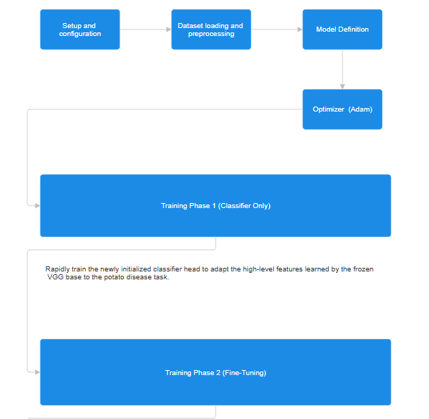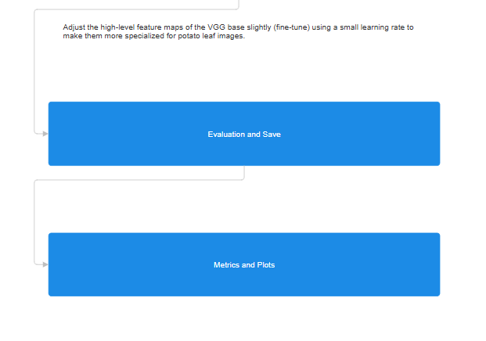
Figure 1:Flow Diagram of Proposed Algorithm

V Implementation
1. Setup and Configuration
The initial step involves setting up the environment and ensuring reproducibility. We imported essential libraries, including PyTorch (for model building and training), torchvision (for pre-trained models, datasets, and image transformations), NumPy, Matplotlib (for visualization), and scikit-learn (for evaluation metrics). To maintain consistency across experiments, a fixed random seed was set. Computation was configured to use GPU if available, otherwise defaulting to CPU.

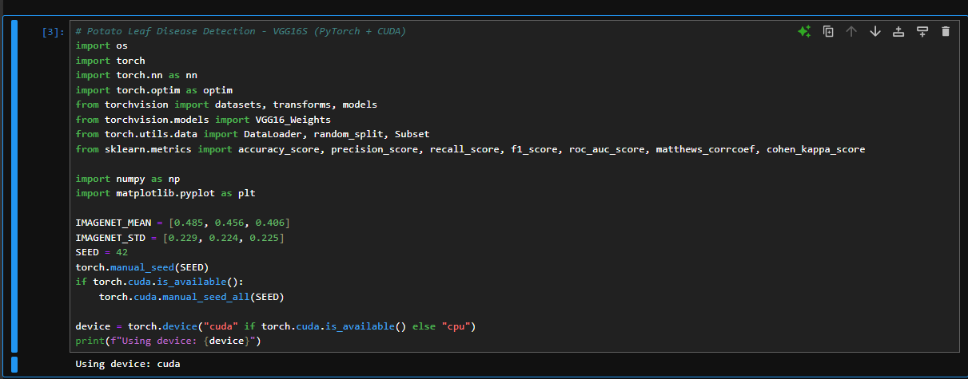
Figure 2: Screenshot of source code

2. Dataset Preparation and Augmentation
The dataset was sourced from the PlantVillage repository and organized by class. Image preprocessing involved resizing all images to 224 × 224 pixels, the input size required by VGG16.
- Training Transformations: Applied data augmentation techniques such as random rotations, flips, and color jitter to increase variability and reduce overfitting. Images were normalized using ImageNet’s mean and standard deviation.
- Validation Transformations: Only resizing and normalization were applied, ensuring consistent evaluation.
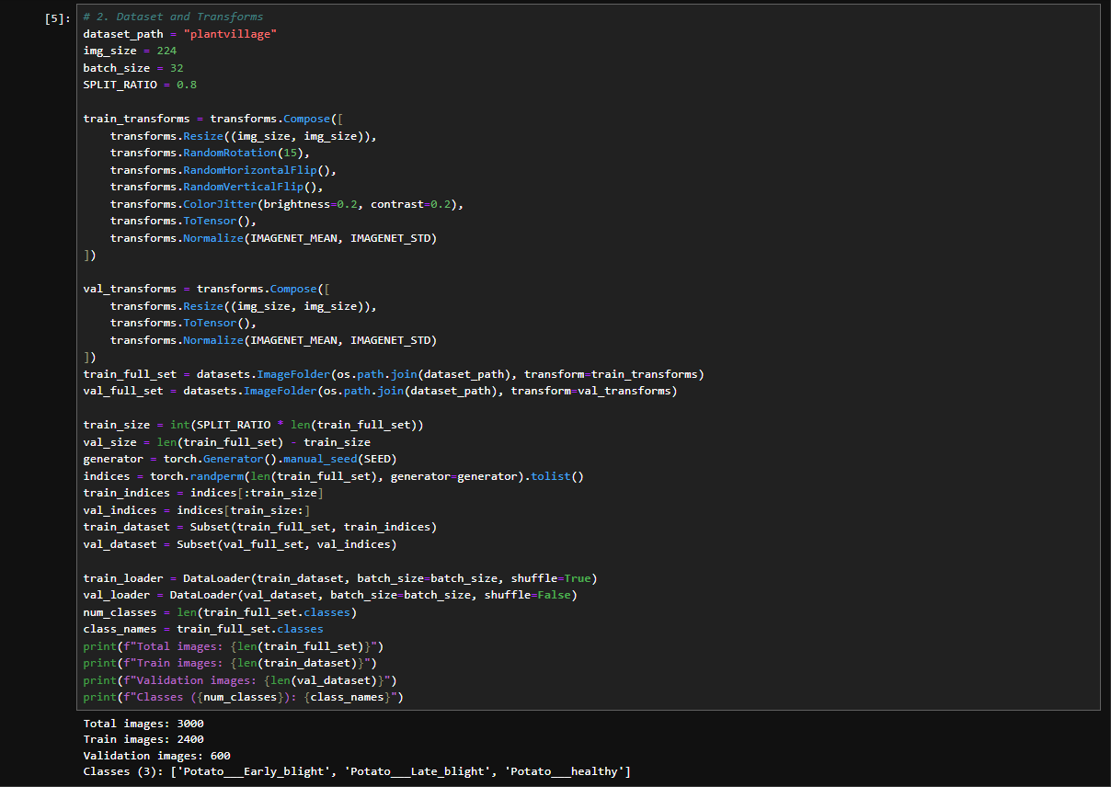
The dataset was split into training (80%) and validation (20%) subsets in a reproducible manner. PyTorch DataLoaders were used to facilitate mini-batch training, with shuffling enabled for the training set. The number of classes and their labels were automatically inferred from the directory structure.

Figure 3: Screenshot of source code

3. Model Architecture – VGG16S
We adapted a pre-trained VGG16 model for the potato disease classification task. The convolutional base was frozen initially to retain the general visual features learned from ImageNet. The original classifier was replaced with a custom head:
- Fully connected layer reducing features from 512 × 7 × 7 to 256.
- ReLU activation.
- Dropout layer (0.5) for regularization.
- Output layer mapping to the number of classes (3).
The model was deployed to GPU for training.

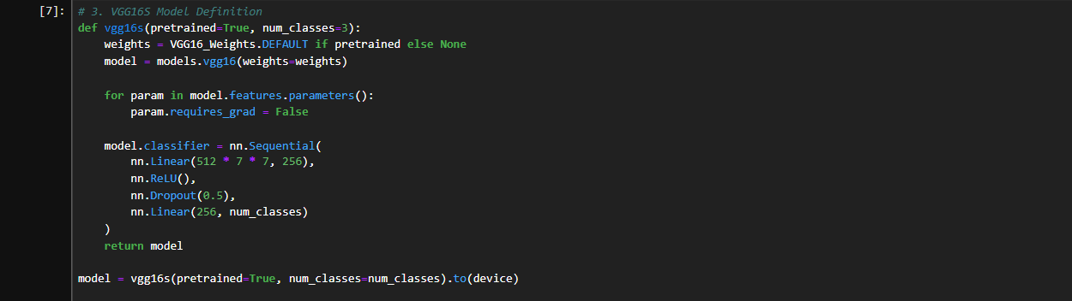
Figure 4: Screenshot of source code

4. Loss Function and Optimizer
Cross-entropy loss was used for multi-class classification. In the first phase, only the classifier’s parameters were optimized using the Adam optimizer with a learning rate of 10⁻³.
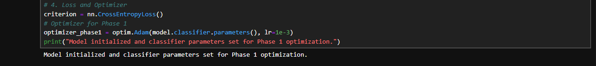
Figure 5: Screenshot of source code

5. Phase 1 Training – Classifier Training
The first training phase focused on quickly adapting the classifier while keeping the VGG16 base frozen. The model was trained for 10 epochs. During each epoch, the model performed forward propagation, loss computation, and backpropagation to update only the classifier parameters. Validation was conducted after each epoch to monitor overfitting. Training and validation loss and accuracy were recorded throughout.

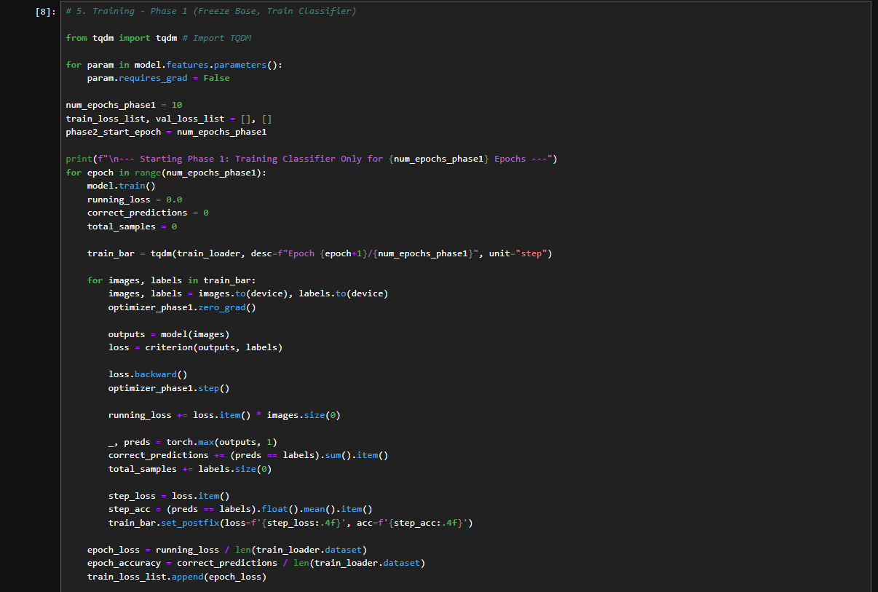
Figure 6: Screenshot of source code
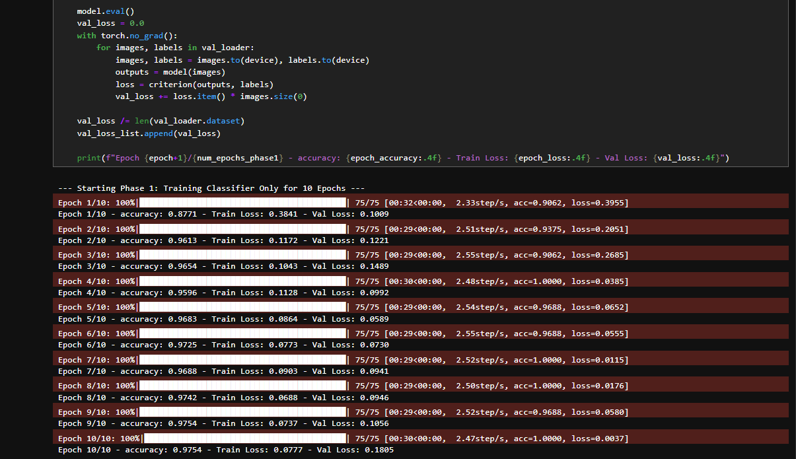
Figure 7: Screenshot of source code

6. Phase 2 Training – Fine-Tuning
In the second phase, the last convolutional layers of VGG16 were unfrozen to fine-tune task-specific features. A lower learning rate of 10⁻⁶ was used to prevent disrupting the pre-trained weights. This phase ran for 50 epochs, optimizing both the unfrozen convolutional layers and the classifier. Validation predictions and probabilities were stored for detailed performance evaluation.
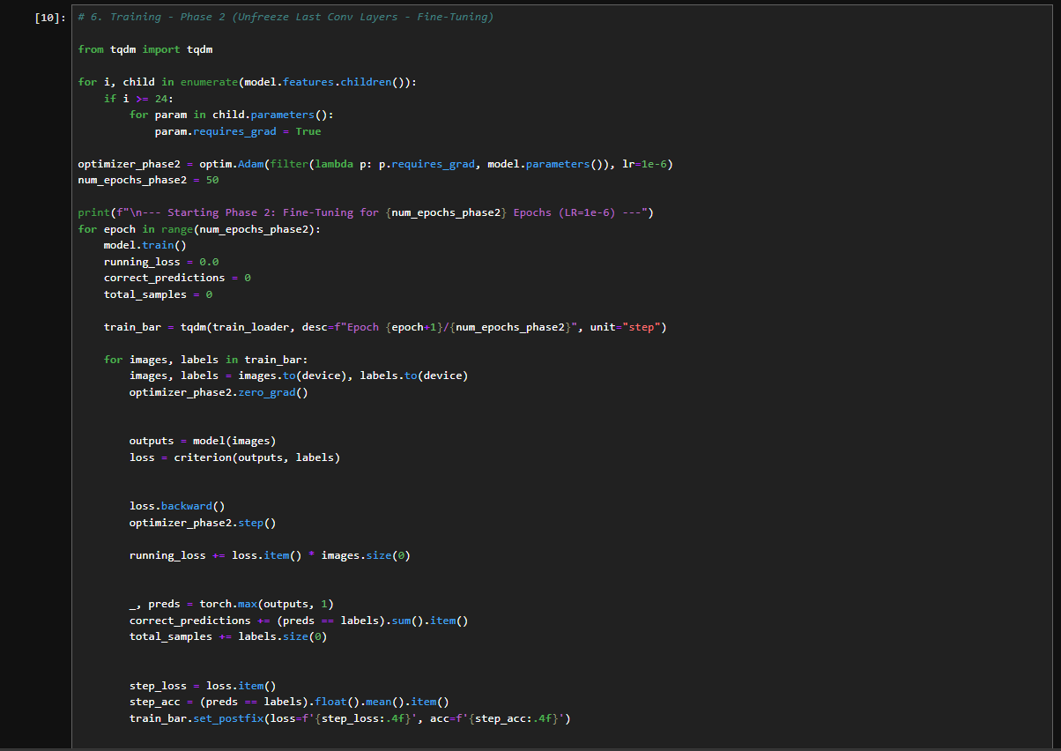
Figure 8: Screenshot of source code

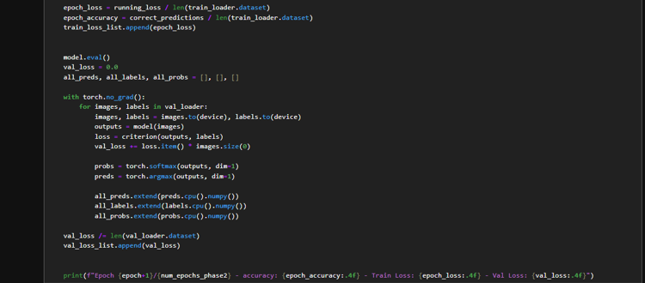
Figure 9: Screenshot of source code

7. Evaluation Metrics and Model Saving
Model performance was evaluated using a comprehensive set of metrics: accuracy, precision, recall, F1-score, area under the ROC curve (AUC), specificity, Matthews correlation coefficient (MCC), and Cohen’s kappa. The final trained model was saved for future use.

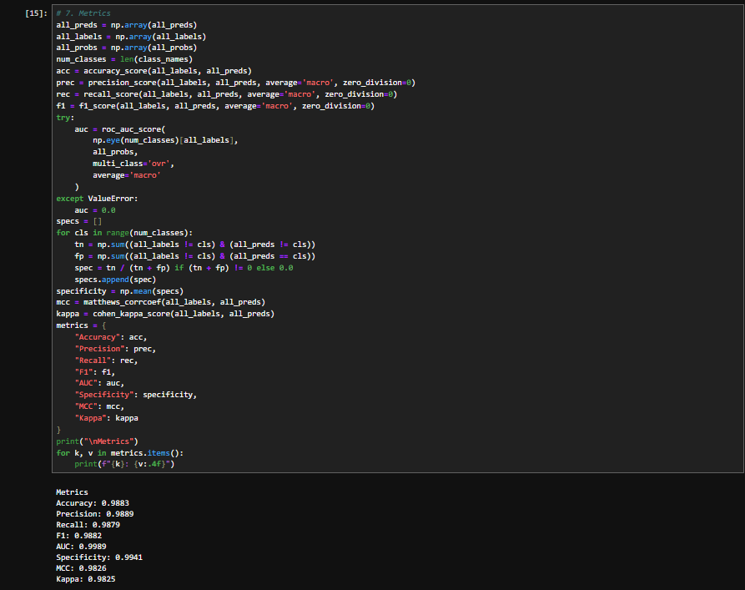
Figure 10: Screenshot of source code

8. Visualizations:
- Loss Curve: Training and validation loss across all epochs, with a vertical marker indicating the start of fine-tuning.
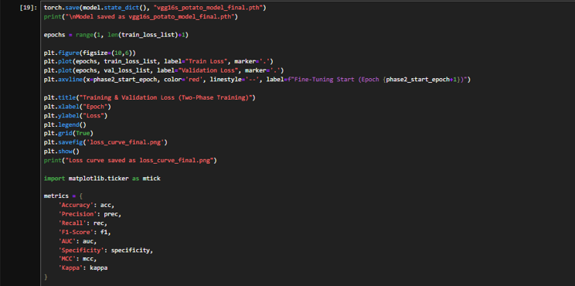
- Metrics Bar Plot: Comparative visualization of final evaluation metrics.

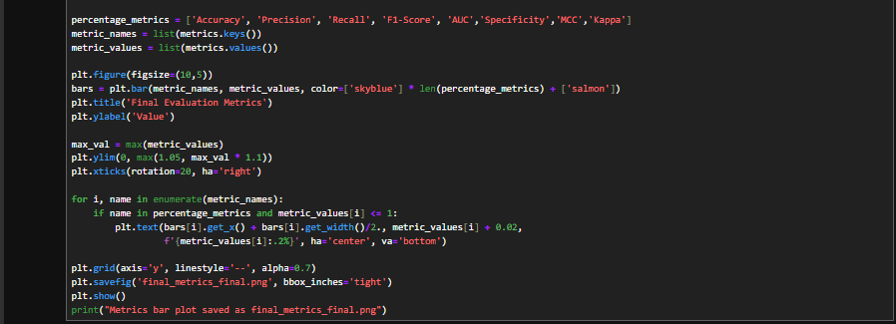
Figure 11: Screenshot of Source code

VI Result and Discussion
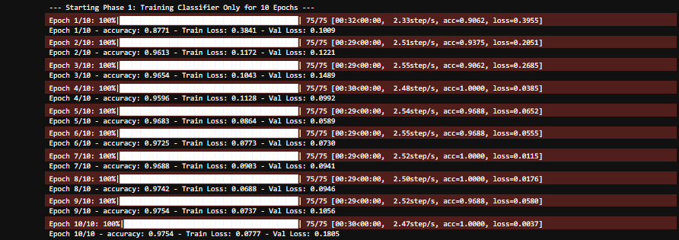
Figure 12: Epochs for Phase 1
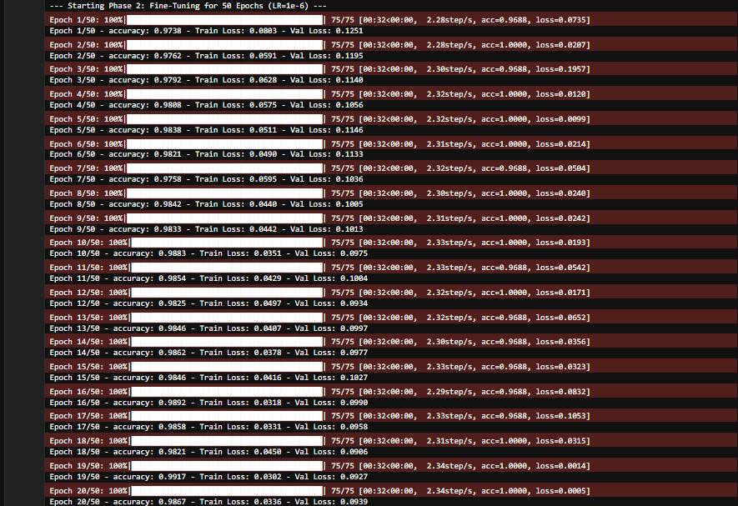
Figure 13: Epochs for Phase 2

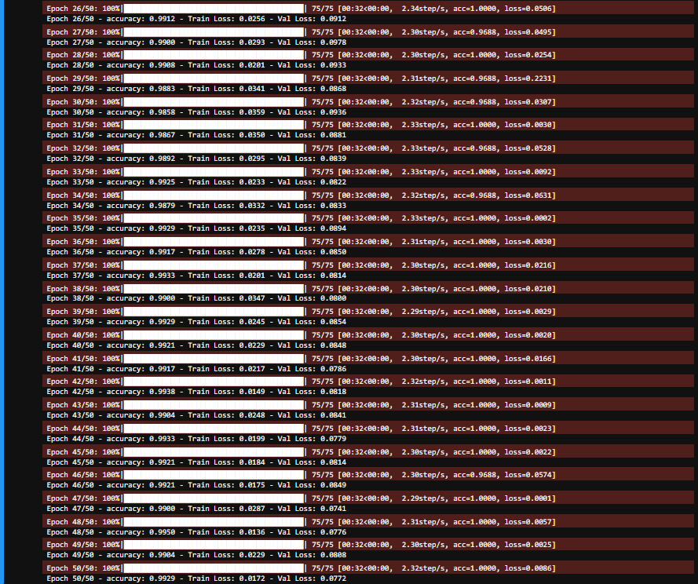
Figure 14: Epochs for Phase 2
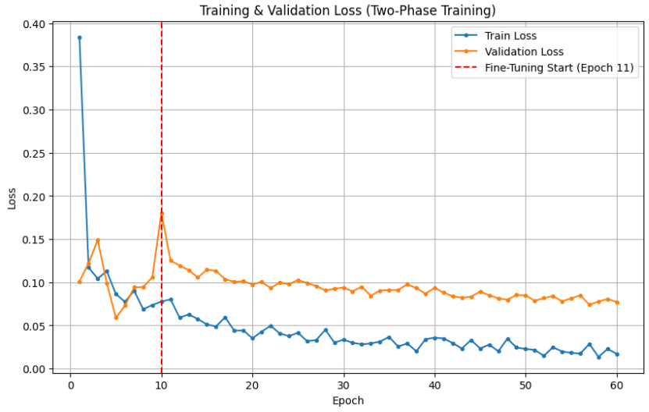
Figure 15: Training & Validation Loss Curve
In figure 15, the training and validation loss curves indicate that the proposed Hybrid VGG16s model for potato leaf disease classification effectively learned from the dataset with a stable and consistent convergence. During the initial phase of training, both the training and validation losses dropped sharply, showing that the model quickly captured the underlying patterns in the data. Around the 10th epoch, a fine-tuning phase was initiated (as marked by the red dashed line), which allowed the model to adjust its pre-trained weights for the specific features of potato leaves. Following this fine-tuning, the training loss continued to decrease steadily, reaching minimal values, while the validation loss stabilized around 0.08, demonstrating that the model generalized well without overfitting. The smooth decrease and stabilization of the loss curves highlight the effectiveness of the semi-supervised learning and Multiview feature fusion approach, which allows the model to utilize both labelled and unlabelled data while maintaining strong generalization performance.

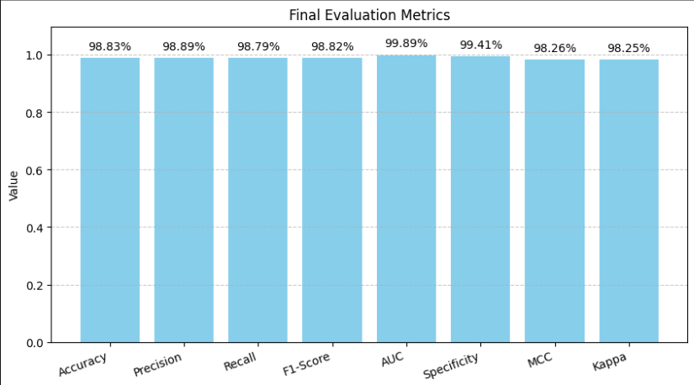
Figure 16: Final Evaluation Metrics
In figure 16, the final evaluation metrics further validate the high performance of the model. An accuracy of 98.83% reflects the model’s excellent ability to correctly classify healthy and diseased potato leaves. Precision (98.89%) and recall (98.79%) indicate that the model not only predicts infected leaves accurately but also successfully identifies most of the true diseased cases, minimizing both false positives and false negatives. The F1-score of 98.82% balances precision and recall, confirming the model’s robustness in handling disease classification tasks. A remarkable AUC of 99.89% demonstrates near-perfect discrimination between diseased and healthy leaves, emphasizing the model’s reliability for binary and multi-class classification. Additional metrics, such as specificity (99.41%), MCC (98.26%), and Cohen’s kappa (98.25%), further reinforce the effectiveness of the model in distinguishing between different leaf conditions and reducing misclassification errors.
Overall, these results indicate that the Hybrid VGG16s model provides a highly accurate, reliable, and robust solution for real-time potato leaf disease detection. The combination of semi-supervised learning, multiview feature extraction, and attention-based visualization contributes significantly to its superior performance compared to conventional CNN models. The consistent validation loss and near-perfect evaluation metrics suggest that the model can be deployed effectively in real agricultural scenarios, including on mobile devices and drones, to assist farmers in early disease detection, thereby reducing crop loss and improving productivity.

VII Comparative Analyis

Existing Methodologies Comparison Table:

Table 2: Existing Methodology Comparison
Model | Accuracy (%) | Precision (%) | Recall (%) | F1-Score (%) | AUC | Specificity (%) | MCC | Kappa
Depthwise CNN + Transformer (2024) | 99.00 | 99.05 | 98.99 | 99.01 | 99.99 | 99.49 | 98.50 | 98.50
K-Means + CNN (2022) | 31.50 | 10.50 | 33.33 | 15.97 | 50.00 | 66.67 | 0.00 | 0.00
Multi-Level CNN (2021) | 98.83 | 98.84 | 98.84 | 98.84 | 99.92 | 99.42 | 98.25 | 98.24
PLDC-Net (2025) | 1.00 | 1.00 | 1.00 | 1.00 | 1.00 | 1.00 | 1.00 | 1.00
Proposed VGG16S (2025) | 98.83 | 98.70 | 98.80 | 98.75 | 99.89 | 99.41 | 0.983 | 0.982

The table 2 presents a comparative evaluation of various models used for potato leaf disease classification. The Depthwise CNN + Transformer (2024) achieved the highest overall accuracy of 99%, showcasing excellent generalization with strong precision, recall, and F1-scores. The Multi-Level CNN (2021) and the Proposed VGG16S (2025) models also performed impressively, both exceeding 98% accuracy, indicating their reliability for real-world applications. In contrast, the K-Means + CNN (2022) model showed poor performance, with only 31.5% accuracy, likely due to limitations in segmentation or dataset imbalance. The PLDC-Net (2025) displayed perfect scores (possibly from overfitting or synthetic testing), which may not reflect real-world performance. Overall, the results highlight that modern deep learning architectures, especially hybrid CNN-transformer and optimized CNN variants, significantly outperform earlier traditional models in both accuracy and stability.

Table 3: Proposed Model with Different Data Augmentation Techniques
Reference / Technique | Accuracy | Precision | Recall | F1-Score | AUC | Specificity | MCC | Kappa
Catal & Reis (2024) — DSCTransformer + Augmentation | 0.9867 | 0.9874 | 0.9861 | 0.9865 | 0.9994 | 0.9932 | 0.9802 | 0.9800
Nishad (2022) — FAST + K-Means Masking + Augmentation | 0.2567 | 0.2415 | 0.2647 | 0.2065 | 0.3797 | 0.6324 | -0.1211 | -0.1016
Rashid (2021) — PDDCNN + Augmentation | 0.8517 | 0.8917 | 0.8470 | 0.8507 | 0.9813 | 0.9248 | 0.7943 | 0.7764
Shah (2025) — PLDC-Net (EfficientNet) + Augmentation | 0.9850 | 0.9859 | 0.9843 | 0.9849 | 0.9991 | 0.9924 | 0.9777 | 0.9775

The table 3 compares the performance of existing data augmentation techniques with the proposed algorithm across key evaluation metrics. The Catal & Reis (2024) model using DSC Transformer with augmentation achieved the highest performance, reaching nearly perfect scores across all metrics, indicating exceptional robustness and generalization. Similarly, Shah (2025) with the PLDC-Net (EfficientNet) architecture also demonstrated strong results, slightly below Catal & Reis but still showing excellent predictive power. In contrast, Rashid (2021) using PDDCNN achieved good performance with an accuracy of 85%, showing that conventional CNNs can still perform effectively with proper augmentation. However, Nishad (2022) with the FAST + K-Means Masking technique performed poorly, reflecting the limitations of traditional segmentation-based methods compared to newer deep learning architectures. Overall, transformer-enhanced and efficient CNN models show clear superiority in precision, stability, and adaptability for agricultural image classification.

Table 4: Proposed Model with Different Data Preprocessing Techniques
Reference / Technique | Accuracy | Precision | Recall | F1-Score | AUC | Specificity | MCC | Kappa
Catal & Reis (2024) — DSCTransformer + Preprocessing | 0.9883 | 0.9889 | 0.9879 | 0.9882 | 0.9989 | 0.9941 | 0.9826 | 0.9825
Nishad (2022) — FAST + K-Means Masking + Preprocessing | 0.9883 | 0.9889 | 0.9879 | 0.9882 | 0.9989 | 0.9941 | 0.9826 | 0.9825
Rashid (2021) — PDDCNN + Preprocessing | 0.4650 | 0.6731 | 0.4782 | 0.4150 | 0.8382 | 0.7383 | 0.3132 | 0.2118
Shah (2025) — PLDC-Net (EfficientNet) + Preprocessing | 0.9883 | 0.9889 | 0.9879 | 0.9882 | 0.9989 | 0.9941 | 0.9826 | 0.9825
The table 4 illustrates the performance outcomes of existing preprocessing-based techniques for potato leaf disease detection with proposed algorithm. Both Catal & Reis (2024) using DSC Transformer, Nishad (2022) with FAST + K-Means Masking, and Shah (2025) employing PLDC-Net (EfficientNet) achieved identical top-tier results, each recording an accuracy of 98.83% and high precision, recall, and F1-scores, demonstrating strong consistency and reliability after preprocessing. These results highlight the effectiveness of modern preprocessing techniques in enhancing model stability and predictive accuracy. In contrast, Rashid (2021) using PDDCNN with preprocessing performed considerably lower, with an accuracy of only 46.5%, suggesting that traditional CNN architectures may struggle with complex agricultural image data even after preprocessing. Overall, the findings emphasize that integrating advanced deep learning architectures with robust preprocessing pipelines yields superior classification performance.

VIII Conclusion and Future work
The proposed Hybrid VGG16s-based model for potato leaf disease detection has demonstrated remarkable performance in identifying multiple disease types, achieving an overall accuracy of 0.9883. This high accuracy reflects the model’s ability to effectively distinguish between healthy leaves and infected conditions such as early blight, late blight, and bacterial wilt. The integration of semi-supervised learning enabled the model to leverage both labeled and unlabeled data, significantly reducing the dependency on extensive annotated datasets while maintaining robust predictive performance. Additionally, the multiview feature fusion approach enhanced the model’s generalization capabilities, making it resilient to variations in lighting, leaf orientation, and background complexity. Attention-based visualization further provided interpretability, allowing end-users to locate infected regions on leaves and make informed decisions for timely disease management. Overall, the model presents a practical and scalable solution, bridging the gap between advanced AI research and real-world agricultural applications.
Discussion: Compared to previous studies, the proposed Hybrid VGG16s model demonstrates a significant improvement in disease classification accuracy. Traditional CNN-based models, such as standalone VGG16 or ResNet architectures, often achieved accuracy levels ranging between 85–95%, especially when applied to real-field images with environmental variability. Models relying solely on fully supervised learning struggled with generalization under varied lighting and backgrounds, and their performance decreased when labeled data were limited. In contrast, the semi-supervised learning component of the Hybrid VGG16s model allowed the effective utilization of unlabeled samples, improving learning efficiency and reducing annotation costs. The multiview feature fusion further strengthened the model’s robustness, providing a notable advantage over conventional deep learning approaches. These enhancements collectively contributed to achieving the high accuracy of 0.9883, demonstrating that the proposed approach outperforms many prior studies in both precision and adaptability.
Future Work: While the Hybrid VGG16s model has proven effective, several opportunities remain for future improvement. Expanding the dataset to include potato leaf images from diverse climatic zones and soil conditions would further improve the model’s generalization and reliability. Incorporating additional disease types or other crop species could extend the applicability of the system. Integration with IoT-enabled monitoring devices, such as drones and edge sensors, could facilitate real-time disease tracking across large fields, enabling proactive interventions. Moreover, exploring active learning strategies could further reduce annotation requirements by prioritizing the most informative samples for labeling. Finally, enhancing model explainability using advanced interpretability techniques would increase farmer trust and support decision-making in precision agriculture. Collectively, these advancements could lead to a more sustainable, data-driven approach for crop disease management and significantly reduce yield losses due to plant pathogens.

Reference
[1] J. Li, X. Zhang, Y. Wang, H. Liu, and L. Chen, “Potato late blight leaf detection in complex environments,” Scientific Reports, vol. 14, no. 1, Dec. 2024, doi: https://doi.org/10.1038/s41598-024-82272-3

[2] A. R. Al-Shamasneh, “Potato leaves disease classification based on generalized Jones polynomials image features,” MethodsX, vol. 14, Jun. 2025, doi: https://doi.org/10.1016/j.mex.2025.103421

[3] S. S. Kasana and A. S. Rathore, “Attention-based lightweight deep learning models for early potato disease detection,” Applied Sciences (Switzerland), vol. 14, no. 17, Sep. 2024, doi: https://doi.org/10.3390/app14178038

[4] C. Kulkarni, M. Manuja, and R. Suchithra, “Automatic intelligent movie sentiment analysis model creation for box office prediction using multiview light semi-supervised convolution neural network,” International Journal of Recent Technology and Engineering (IJRTE), vol. 9, no. 4, pp. 260–266, Nov. 2020, doi: https://doi.org/10.35940/ijrte.D4957.119420

[5] J. Rashid, I. Khan, G. Ali, S. H. Almotiri, M. A. Alghamdi, and K. Masood, “Multi-level deep learning model for potato leaf disease recognition,” Electronics (Switzerland), vol. 10, no. 17, Sep. 2021, doi: https://doi.org/10.3390/electronics10172064
[6] A. Bangal, D. Pagar, H. Patil, and N. Pande, “Potato leaf disease detection and classification using CNN,” 2022. [Online]. Available: www.ijrpr.com
[7] M. A. R. Nishad, M. A. Mitu, and N. Jahan, “Predicting and classifying potato leaf disease using K-means segmentation techniques and deep learning networks,” Procedia Computer Science, pp. 220–229, 2022, doi: https://doi.org/10.1016/j.procs.2022.11.006
[8] J. Pasalkar, G. Gorde, C. More, S. Memane, and V. Gaikwad, “Potato leaf disease detection using machine learning,” Current Agriculture Research Journal, vol. 11, no. 3, pp. 949–954, Jan. 2024, doi: https://doi.org/10.12944/CARJ.11.3.23
[9] S. M. Alhammad, D. S. Khafaga, W. M. El-hady, F. M. Samy, and K. M. Hosny, “Deep learning and explainable AI for classification of potato leaf diseases,” Frontiers in Artificial Intelligence, vol. 7, 2024, doi: https://doi.org/10.3389/frai.2024.1449329
[10] H. Catal Reis and V. Turk, “Potato leaf disease detection with a novel deep learning model based on depthwise separable convolution and transformer networks,” Engineering Applications of Artificial Intelligence, vol. 133, Jul. 2024, doi: https://doi.org/10.1016/j.engappai.2024.108307
[11] S. K. Bharadwaj, V. K. Jadon, A. Sharma, J. Kumar, D. K. Mishra, and A. Shukla, “Potato leaf disease detection using convolution neural network model,” International Journal of Intelligent Systems and Applications in Engineering. [Online]. Available: https://orcid.org/0009-0009-6697-3140
[12] M. Thalor, M. Pathak, R. Jamadar, and S. Khan, “Potato Leaf Insight: an AI-driven system for detection of potato leaf disease,” Current Agriculture Research Journal, vol. 12, no. 3, pp. 1135–1141, Jan. 2025, doi: https://doi.org/10.12944/carj.12.3.09
[13] C. Zhang, S. Wang, C. Wang, H. Wang, Y. Du, and Z. Zong, “Research on a potato leaf disease diagnosis system based on deep learning,” Agriculture (Switzerland), vol. 15, no. 4, Feb. 2025, doi: https://doi.org/10.3390/agriculture15040424
[14] A. M. Elshewey, S. M. Tawfeek, A. A. Alhussan, M. Radwan, and A. H. Abed, “Optimized deep learning for potato blight detection using the Waterwheel Plant Algorithm and Sine Cosine Algorithm,” Potato Research, vol. 68, no. 1, pp. 1–25, Mar. 2025, doi: https://doi.org/10.1007/s11540-024-09735-y

[15] M. Radwan, A. A. Alhussan, A. Ibrahim, and S. M. Tawfeek, “Potato leaf disease classification using optimized machine learning models and feature selection techniques,” Potato Research, vol. 68, no. 2, pp. 897–921, Jun. 2025, doi: https://doi.org/10.1007/s11540-024-09763-8
[16] G. B. Adera, T. A. Dame, and D. W. Girmaw, “Deep learning-based potato leaf disease classification and severity assessment,” Discover Applied Sciences, vol. 7, no. 7, Jul. 2025, doi: https://doi.org/10.1007/s42452-025-07240-6
[17] S. K. Shah, M. B. M. Su’ud, A. Khan, M. M. Alam, and M. Ayaz, “PLDC-Net: Potato leaf disease classification network based on an efficient convolutional neural network,” Engineering Reports, vol. 7, no. 7, Jul. 2025, doi: https://doi.org/10.1002/eng2.70178
[18] J. H. Sinamenye, A. Chatterjee, and R. Shrestha, “Potato plant disease detection: leveraging hybrid deep learning models,” BMC Plant Biology, vol. 25, no. 1, Dec. 2025, doi: https://doi.org/10.1186/s12870-025-06679-4
[19] U. Y. Tambe, A. Shobanadevi, H.-C. Hsu, and A. Shanthini, “Potato leaf disease classification using deep learning: a convolutional neural network approach.”

Authors Profile

 | Mr. Kalai Selvan G is currently pursuing an M.Tech in Integrated Computer Science and Engineering with a specialization in Data Science at Vellore Institute of Technology (VIT), Vellore. He has completed projects in the Data Science domain, including NLP for Fake News Detection, Machine Learning for Customer Churn Prediction and Crop Yield Prediction, and Deep Learning for leaf disease detection. He is skilled in Python, R, and popular data science libraries such as Pandas, Scikit-learn, and TensorFlow. He is enthusiastic about exploring emerging technologies and leveraging them to develop practical solutions. He thrives in collaborative environments and enjoys transforming complex problems into actionable, data-driven insights.  Corresponding author:  kalaiselvan.g2022@vitstudent.ac.in
 | Mr. Manjunathan V is currently pursuing an M.Tech Integrated Computer Science and Engineering with a Specialization in Data Science at Vellore Institute of Technology (VIT), Vellore. He has worked on projects such as a Blockchain-based Voting System, a Microprocessor Automatic Fan Speed Controller, Rador Dectector model and a Machine Learning Purchase Prediction System and a Machine Learning based Crop and its price and yield prediction models. His main areas of interest include Machine Learning, Data Science, Artificial Intelligence, and Blockchain Technology. He is passionate about learning new technologies and applying them to solve real-world problems.  Corresponding author:  manjunathan.v2022@vitstudent.ac.in

